TITLE OF THE INVENTION
EduShild: An Interactive Cybersecurity Toolkit For Awareness and Education

OVERVIEW OF THE DESCRIPTION
The innovation that is to be carried out are specifically and described in the following specification information in the data.

FIELD OF THE INNOVATION
The fields of computer network security and cybersecurity are related to the current invention. The invention specifically pertains to a computerized system & technique for dynamic phishing awareness and URL risk assessment that uses heuristic-based evaluation approaches and controlled phishing simulation to improve phishing detection capabilities and educate users.

The History of the Invention:

The growing dependence on internet-based services has made phishing attacks one of the most common cyber threats. Phishing attacks generally leverage human nature and false emotions, such as confidence, dread, and fear, to trick people into divulging important information, in contrast to traditional hacks that use technological flaws.

Modern phishing defenses include rule-based detection systems, browser warnings, blacklist-style detection, and predictive classifiers. Although these techniques offer technological security, they are primarily passive defenses with little instructional value. The majority of awareness campaigns focus on static content, such as articles with videos, which do not offer hands-on training or exposure to real phishing techniques.

Additionally, many of the phishing detection techniques used today are "black-box" systems that don't explain why a particular URL or behavior is flagged as suspicious. As a result, users are unable to develop autonomous threat detection skills and keep depending on automated notifications.

A technical solution that integrates live phishing simulation with simple threat evaluation is necessary to assist users in understanding phishing assaults from both the perpetrator's and defender's viewpoints in a safe setting.

The invention's goals
Providing a user-friendly phishing awareness and identification tool is the main goal of the current idea.
Additional items of the invention consist of:
- to model phishing attack situations in a safe and moral setting.
- to illustrate how user credentials may be obtained using dishonest interfaces.
- to use heuristic phishing indicators for URL analysis.
- to give clear explanations for the outcomes of phishing detection.
- to raise user awareness and encourage protective actions against phishing scams.
- to close the knowledge gap between theory and practice in cybersecurity
A SUMMARY OF THE INVENTION

One of the pressing issues in the present day is to protecting people from phishing attempts through easily accessible and engaging teaching materials. The goal of the undertaking "Integrated Cybersecurity: An Educational Toolkit for Phishing Awareness as well as Defense" is to address this problem. Phishing is a significant cyber threat because it uses psychological tricks rather than technology flaws. At the moment, countermeasures such as browser plugins, blacklists, and education training for companies do not always successfully reach or include regular people.

URL Analyzer: This defense tool evaluates the authenticity of web URLs using phishing signs such as IP-based domains, questionable terms, administrative validity verification, and obfuscation tactics.

Phishing Demo Server: This malicious educational simulation enables users safely learn how attackers work by showing in real time how phishing attacks obtain user credentials via a phony login page.

When combined, these resources offer a dual-perspective educational setting that enables users to assess threats while also demonstrating how attacks like this are carried out. Even for non-technical learners, this hands- on approach makes difficult cybersecurity concepts more relatable, memorable, and approachable.

BRIEF DESCRIPTION OF THE DRAWINGS
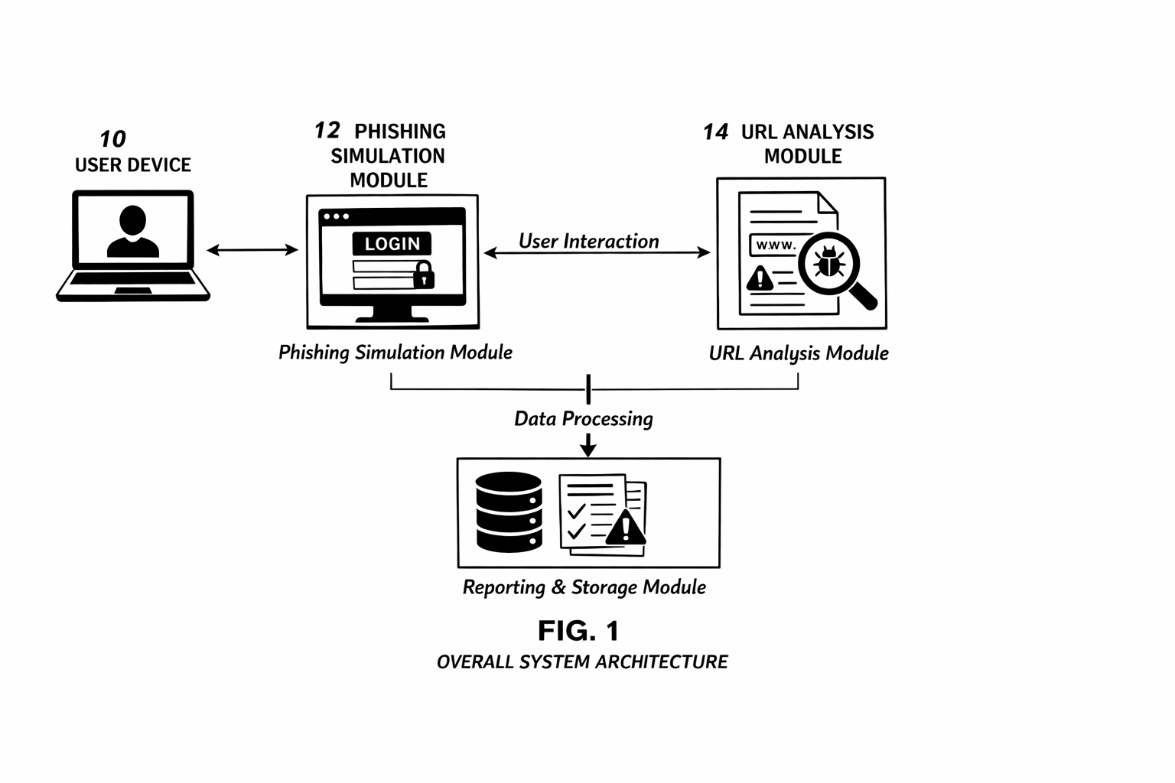

Figure 1 illustrates the overall architecture of the interactive phishing awareness system.

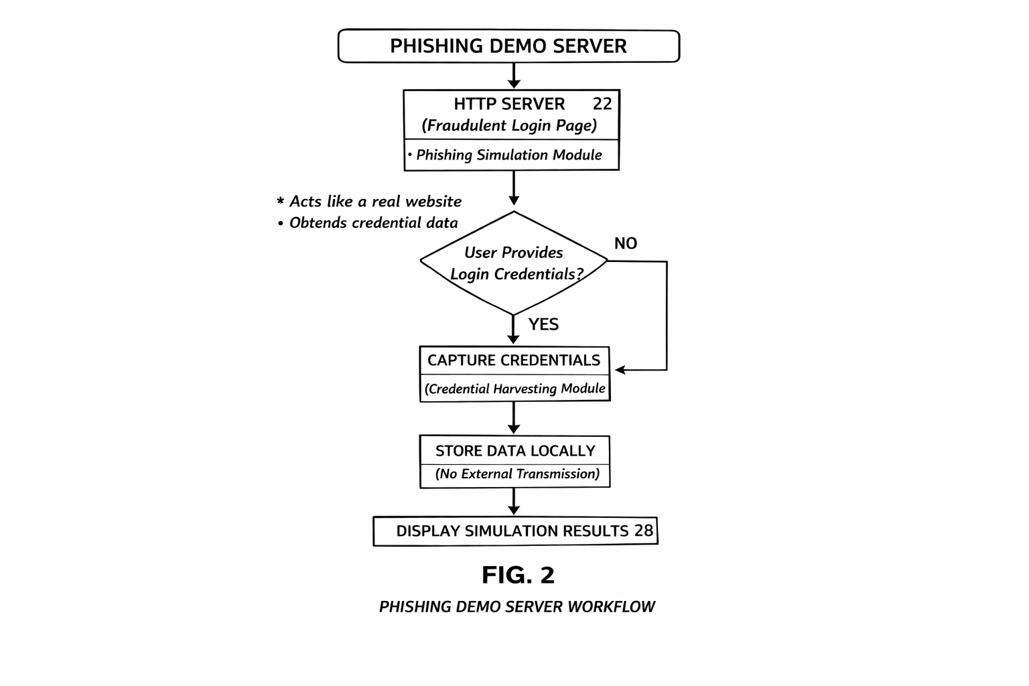

Figure 2 illustrates the workflow of the phishing simulation module.

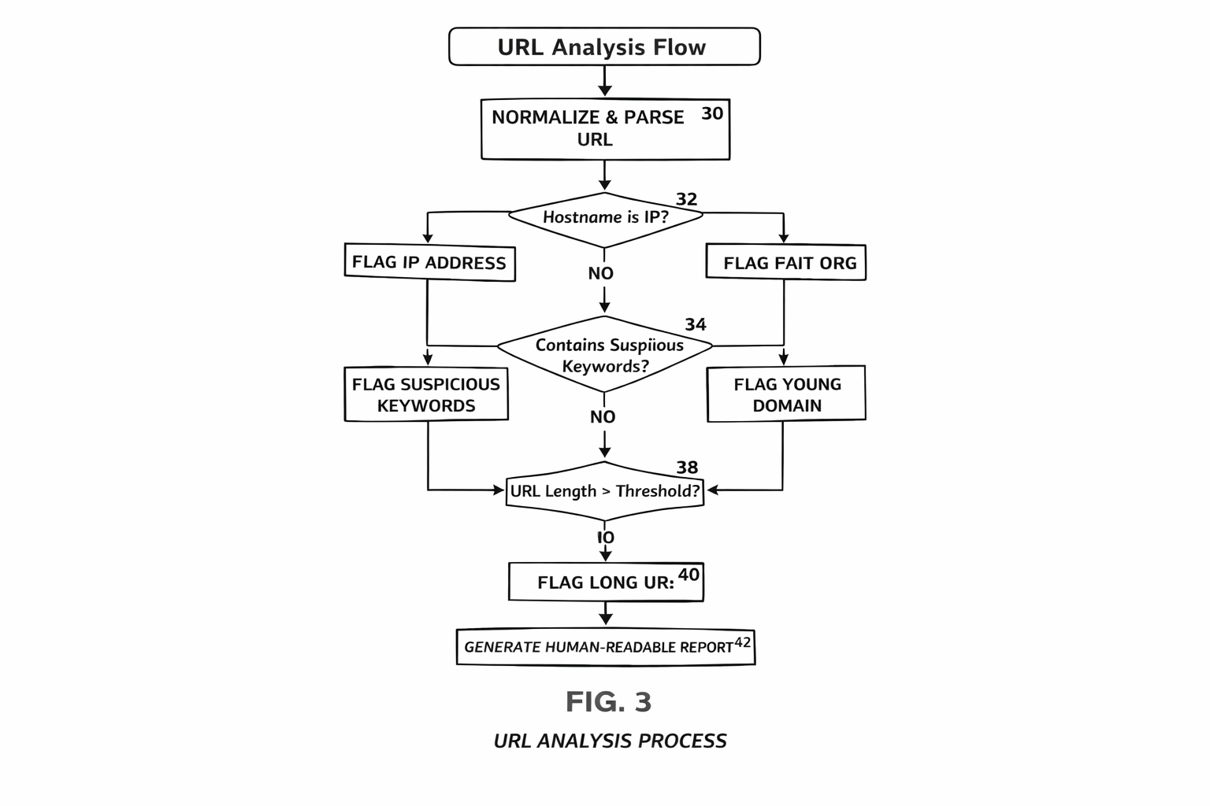

Figure 3 illustrates the URL threat analysis process.

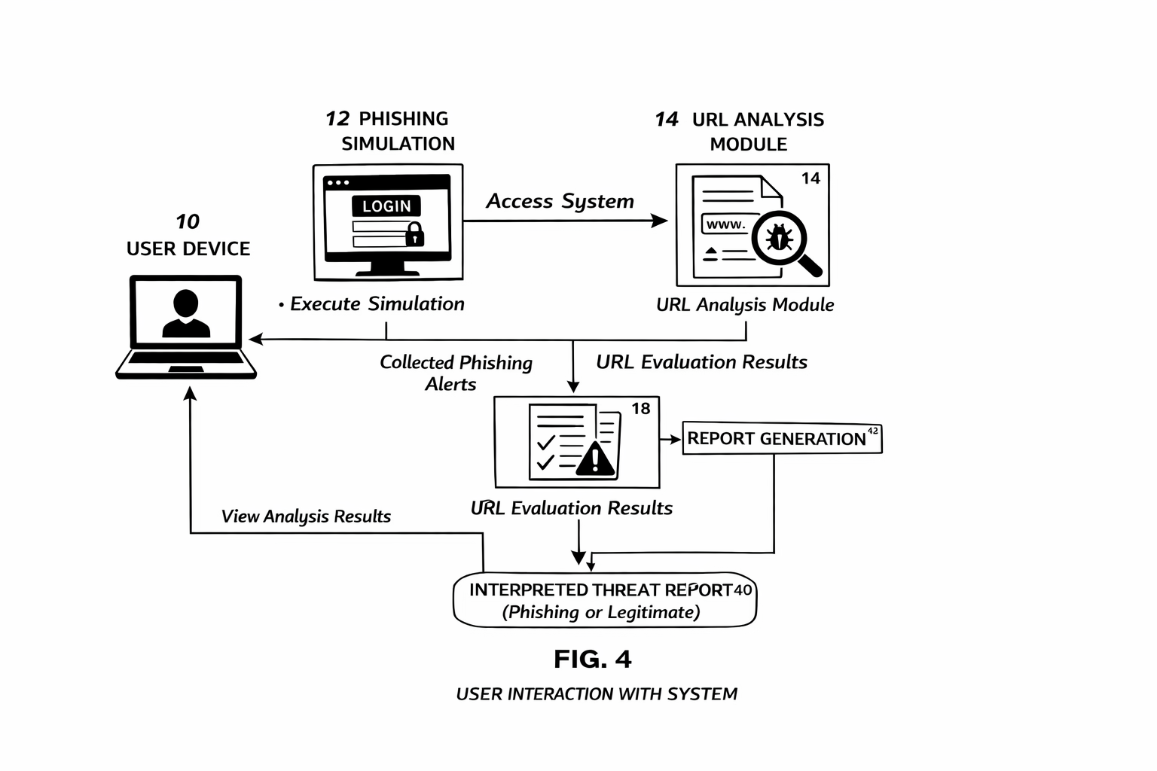

Figure 4 illustrates user interaction and result reporting.
CLAIMS

We assert:

- A computer-implemented phishing awareness system that consists of a simulation module that uses a deceptive user interface to demonstrate credential capture, a URL analysis module that uses heuristic phishing indicators to evaluate web addresses, and a reporting module that provides a user with comprehensible threat explanations.
- The system described in claim 1 uses domain age, keyword presence, URL length, and domain structure as heuristic indicators.
- The system described in claim 1, in which there is no external data transmission and the simulation module functions in a controlled environment.
- The system described in claim 1, wherein the reporting module produces explanations of detected phishing indications that are intelligible to humans.
- The system as stated in claim 1, which uses defensive analysis and attacker behavior to demonstrate dual-perspective learning.

